**Lab Manual for Embedded System Design**

**Lab No. 12**

**Introduction to Raspberry Pi and Python**

**Language**

*Objectives*

*Familiarize yourself with Raspberry-Pi and its developing environment. Familiarize yourself with Python Language Programming.*

**LAB # 12**

**Introduction to Raspberry Pi and Python Language**

# Introduction

***Raspberry******-Pi:***

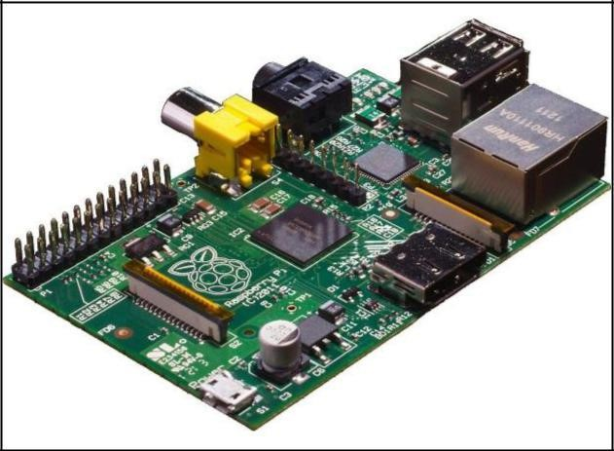The Raspberry-Pi is an ARM powered credit card computer developed by the Raspbian-Pi Foundation for educational and hobbyist purposes.

The Raspberry Pi 3 Model B features a quad-core 64bit ARM Cortex A53 clocked at 1.2 GHz. It has a Broadcom BCM2837 system on a chip (SoC). It has 4 USB ports. It has 1 GB memory. The feature of the Pi 3 is the built-in WiFi and Bluetooth. It uses an SD card for booting and persistent storage. Figure 1 shows Raspberry-Pi peripheral details.

Figure 1: Raspberry – Pi Board B

***Raspberry-Pi Operating System:***

Raspbian is a free operating system based on Debian Optimized for the Raspberry-Pi Hardware. It is precompiled with sets of basic programs that make your Raspberry-Pi run. However, Raspbian provides more than a pure OS. It cones over 35,000 packages, pre-compiled software bundled in a nice format for easy installation on your Raspberry-Pi.

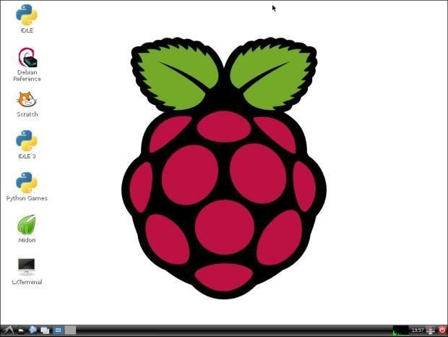

Figure 2: Raspbian Desktop

***Programming with Python:***

Python is a widely used general-purpose, high-level programming language. Its design philosophy emphasizes code readability, and its syntax allows programmers to express concepts in fewer lines of code than would be possible in languages such as C++ or Java. Python is a wonderful and powerful programming language that's easy to use (easy to read and write) and with Raspberry Pi lets you connect your project to the real world. Python syntax is very clean, with an emphasis on readability and uses standard English keywords. Start by opening IDLE from the desktop.

The easiest introduction to Python is through IDLE, a Python development environment.

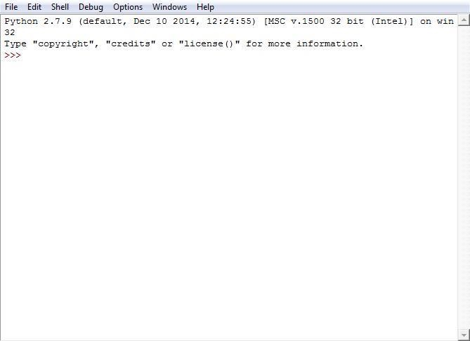

Figure 3: IDLE Python GUI

# Time Boxing

|  |  |  |
| --- | --- | --- |
| **Activity Name** | **Activity Time** | **Total Time** |
| Login Systems + Setting up Raspberry PI Environment | 3 mints + 5 mints | 8 mints |
| Walk through Theory & Tasks | 60 mints | 60 mints |
| Implement Tasks | 80 mints | 80 mints |
| Evaluation Time | 30 mints | 30 mints |
|  | Total Duration | 178 mints |

# Objectives

To Study the SOP Implementation with Multiplexer. To Study the Full Adder Design using Multiplexer. To Study the Basic ALU Design using Multiplexer.

# Lab Tasks/Practical Work

1. In this task we will write a simple Python script in IDLE to calculate the Percentage by taking the Marks of the courses as input.

*print “Welcome to Bahria University (Karachi Campus)”*

* 1. *= input (“Enter Marks Obtained in the Course of E.N.A: ”)*

* 1. *= input (“Enter Marks Obtained in the Course of SIGNALS AND SYSTEMS: ”)*

* 1. *= input (“Enter Marks Obtained in the Course of COMPUTER ARCHITECTURE: ”) total_marks = a+b+c*

*print “Total Marks Obtained are: ”, total_marks percentage = float(total_marks) * (100 / 300) print “Percentage is: ”, percentage*

1. In this task we will write a simple Python script to check that the input number is either even or odd.

* 1. *= input (“Enter Number: ”)*

*if (a == 0):*

*print “Entered Number is Zero.”*

*elif (a % 2 == 0):*

*print “Entered Number is Even.”*

*else:*

*Print “Entered Number is Odd.”*

1. Write Python Script for Calculator which can perform simple operations of Addition, Subtraction, Multiplication and Division.

**Solution:**

def calculator():

while True:

# Get the user's input

num1 = input("Enter a number (or 'q' to quit): ")

if num1 == 'q':

break

num2 = input("Enter another number: ")

if num2 == 'q':

break

operator = input("Enter an operator (+, -, *, /): ")

# Convert the numbers to floats

try:

num1 = float(num1)

num2 = float(num2)

except ValueError:

print("Invalid input. Please try again.")

continue

# Perform the calculation

if operator == '+':

result = num1 + num2

elif operator == '-':

result = num1 - num2

elif operator == '*':

result = num1 * num2

elif operator == '/':

result = num1 / num2

else:

print("Invalid operator. Please try again.")

continue

# Print the result

print(result)

calculator()

**Output:**

Enter a number (or 'q' to quit): 2

Enter another number: 4

Enter an operator (+, -, *, /): +

6.0

Enter a number (or 'q' to quit): 4

Enter another number: 2

Enter an operator (+, -, *, /): -

2.0

Enter a number (or 'q' to quit): 6

Enter another number: 2

Enter an operator (+, -, *, /): *

12.0

Enter a number (or 'q' to quit): 8

Enter another number: 2

Enter an operator (+, -, *, /): /

4.0

Enter a number (or 'q' to quit): q

1. Write ten main Raspberry-Pi application projects. Briefly discuss their details.

1. [Add a Button to a Raspberry Pi](https://www.makeuseof.com/tag/add-button-raspberry-pi-project/):

Adding a button is best done using a breadboard and additional wiring, resistor, and the RPi.GPIO library. If you’re also new to electronics, this project is ideal; it also has an element of programming in Python, which will help any beginner to understand the importance of the Raspberry Pi's GPIO.

2. [Control LED Lights With Raspberry Pi](https://www.makeuseof.com/tag/raspberry-pi-control-led/):

This involves building a simple LED circuit using a breadboard, two LEDs, two resistors, and suitable wires. Once set up, you'll develop knowledge of Python, breadboards, and learn how to safely connect LEDs and other components.

3. [Pi-Powered Motion Sensor and Alarm](http://pimylifeup.com/raspberry-pi-motion-sensor/):

Creating a simple motion sensor and piezo buzzer alarm will teach you the basics of working with external hardware with the Pi, and this project uses Python, so you'll start learning a bit of that, too.

4. [Add a Power Button to Your Raspberry Pi](https://www.makeuseof.com/tag/add-power-button-raspberry-pi/)

One of the cost-saving measures of the Raspberry Pi is that it doesn't include a power switch. Instead, you safely shut down using the operating system and power off when this has completed. Alternatively, you could add your own. Adding a power button is one of the most basic Raspberry Pi projects for beginners, suitable for Raspberry Pi Zero and Raspberry Pi 4 as well as standard models.

1. [Make Your Printer Wireless](https://www.makeuseof.com/tag/make-wireless-printer-raspberry-pi/)

With one of the easiest Raspberry Pi projects, you can make an old printer wireless with a few simple commands. If your Pi model doesn't have built-in Wi-Fi, you can buy [a $10 Wi-Fi dongle](https://www.amazon.com/Edimax-EW-7811Un-150Mbps-Raspberry-Supports/dp/B003MTTJOY?linkCode=ll1&tag=makeusw-20&linkId=cd7029f0324834cd3f07468a4d68520a&language=en_US&ref_=as_li_ss_tl&ascsubtag=UUmuoUeUpU37000). Simply insert the Wi-Fi dongle, plug in your printer, enter some commands, and remote printing will be enabled in minutes.

6. [Make Music with Sonic Pi](http://sonic-pi.net/)

Sonic Pi turns your Raspberry Pi into a music-coding machine, letting you use basic programming skills to make music. This can be anything from sound effects and short samples to full-length songs. Sonic Pi comes preinstalled with Raspberry Pi OS, making it a perfect Raspberry Pi beginner project for anyone with some musical ability.

7. [Build a Network Game Server](https://www.makeuseof.com/tag/raspberry-pi-game-servers/)

Particularly suited to more recent Raspberry Pi models, game server projects are remarkably straightforward. All you need to do is make sure the Pi is connected to your network, then install the server software for your preferred game from the command line.Various games have servers that will run on the Pi, including Minecraft and Quake. If you have any compatible games running on another device, you can set up network play sessions on your Pi.

8. [Connect Dual 4K Monitors to a Raspberry Pi 4 or 400](https://www.makeuseof.com/4k-dual-monitor-setup-with-raspberry-pi/)

If you have two suitable HDMI monitors, you’ll also need a pair of micro-HDMI to HDMI cables. Support for dual displays is built into Raspberry Pi OS, which makes set up particularly straightforward. If you’re comfortable connecting a computer to a monitor, this is the perfect Raspberry Pi beginner project.

9. [Build a Cryptocurrency Price Ticker](https://www.makeuseof.com/build-cryptocurrency-price-ticker-using-raspberry-pi/)

You’ll need a Raspberry Pi 3 or later with an attached display, preferably something pretty compact like a HyperPixel, rather than a larger wall-hanging TV. Once everything is set up, you’ll have a Raspberry Pi that displays the latest cryptocurrency prices, sourced from markets including CoinGecko, Binance, Coinbase Pro, Kraken, and many others.

10. [Set Up an Android Tablet as a Raspberry Pi Display](https://www.makeuseof.com/tag/android-tablet-screen-raspberry-pi/)

With this project, you can wirelessly connect an Android tablet to the Pi for use as a display. No cables are required, no wiring is necessary, and there is little software to install. But by the end you’ll have a handy portable display that lets you use your Raspberry Pi anywhere you can plug it in.